**Aim:**

To evaluate the usability, user satisfaction, and overall experience of the Time Travelling App, focusing on ease of navigation, engagement, and user interaction with key features.

**Procedure:**

1. **Identify Target Users:**
   * Select a diverse group of participants, including history enthusiasts, sci-fi fans, and general users interested in innovative technology.
2. **Define Key Metrics:**
   * Usability: Task completion time, error rate, and ease of use
   * User Satisfaction: User feedback, Net Promoter Score (NPS)
   * Engagement: Time spent on the app, frequency of use, and feature utilization
3. **Design Test Scenarios:**
   * Scenario 1: Onboarding and initial setup
   * Scenario 2: Navigating through different time periods
   * Scenario 3: Interacting with key features such as time travel booking and historical event exploration
   * Scenario 4: Customizing personal timelines and saving favorite journeys
4. **Conduct the Experiment:**
   * **Preparation:**
     + Brief participants on the app’s purpose and how the testing will be conducted.
   * **Execution:**
     + Users perform tasks under observation.
     + Record screen interactions and collect real-time feedback through interviews and surveys.
   * **Observation:**
     + Monitor user interactions, noting any difficulties or positive interactions.
5. **Analyze Data:**
   * Quantitative Analysis: Measure task completion rates, error rates, and engagement metrics.
   * Qualitative Analysis: Summarize user feedback and identify recurring themes or issues. 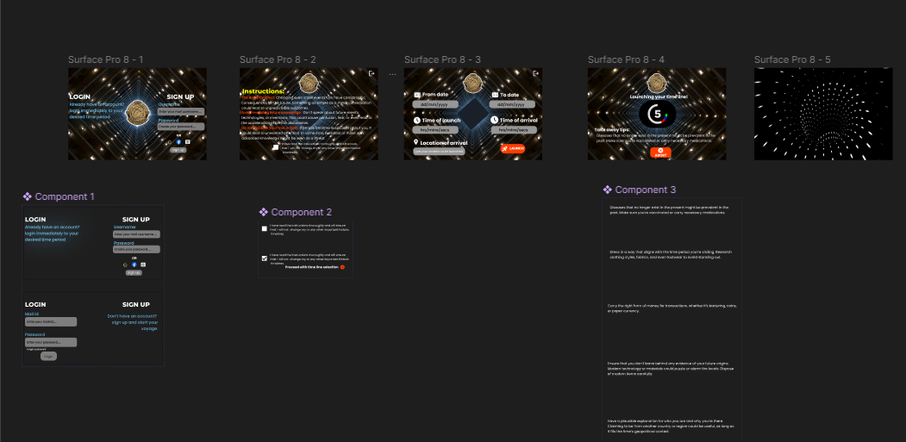

**Result:**

Based on the analysis, you might find:

* **Strengths:** Users found the interface visually appealing and appreciated the historical accuracy of the content.
* **Weaknesses:** Some users experienced difficulty navigating between different time periods, indicating a need for improved navigation controls or clearer instructions.
* **Actionable Insights:**
  + Enhance navigation features to make time period selection more intuitive.
  + Improve onboarding instructions to better guide users through the app’s features.
  + Add interactive tutorials to help users quickly understand how to use advanced features.